ROUTING PROTOCOLS

**There are total 6 protocols:-**

1. RIP (Routing Information Protocol)
2. IGRP (Interior Gateway Routing Protocol)
3. EIGRP (Enhanced Interior Gateway Routing Protocol)
4. OSPF (Open Shortest Path First)
5. IS-IS (Intermediate System-Intermediate System)
6. BGP (Border Gateway Protocol)

RIP PROTOCOL:-

RIP Protocol is a distance vector protocol used in local area networks(LANs) and smaller networks for routing data.  
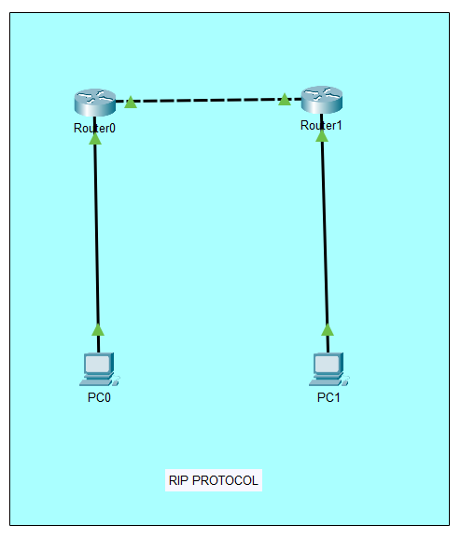  
In the above architecture I have taken 2 PCs and 2 Routers.  
I have connected PCs to Routers via Copper Straight Through wire.  
I have connected Router to Router via Copper Cross-Over.

**PC Configuration:-**

On PC0:  
IP Address: 192.168.1.10

Subnet Mask: 255.255.255.0

Default Gateway: 192.168.1.1

On PC1:  
IP Address: 192.168.2.10

Subnet Mask: 255.255.255.0

Default Gateway: 192.168.2.1

**Router Configuration:-**

On Router0:

enable

conf t

hostname R0

interface g0/0

ip address 192.168.1.1 255.255.255.0

no shutdown

interface g0/1

ip address 10.0.0.1 255.255.255.252

no shutdown

router rip

version 2

network 192.168.1.0

network 10.0.0.0

no auto-summary

end

wr  
  
On Router1:  
enable

conf t

hostname R1

interface g0/0

ip address 192.168.2.1 255.255.255.0

no shutdown

interface g0/1

ip address 10.0.0.2 255.255.255.252

no shutdown

router rip

version 2

network 192.168.2.0

network 10.0.0.0

no auto-summary

end

wr

**Connectivity:-**On PCO-ping 192.168.2.10  
On PC1-ping 192.168.1.10

EIGRP PROTOCOL:-  
EIGRP Protocol is an advanced distance vector protocol developed by cisco it works well in larger networks.  
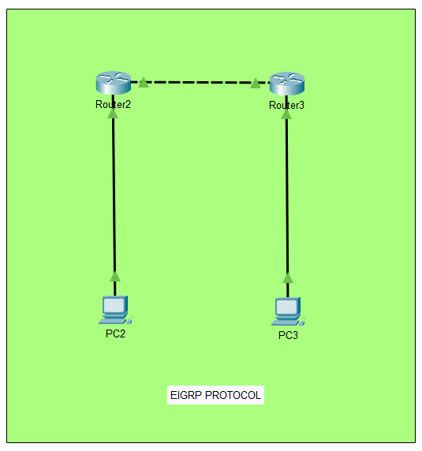

In the above architecture I have taken 2 PCs and 2 Routers.  
I have connected PCs to Routers via Copper Straight Through wire.  
I have connected Router to Router via Copper Cross-Over.

**PC Configuration:-**

On PC2:  
IP Address: 192.168.10.10

Subnet Mask: 255.255.255.0

Default Gateway: 192.168.10.1

On PC3:  
IP Address: 192.168.20.10

Subnet Mask: 255.255.255.0

Default Gateway: 192.168.20.1  
**Router Configuration:-**

On Router2:

enable

conf t

hostname R2

interface g0/0

ip address 192.168.10.1 255.255.255.0

no shutdown

interface g0/1

ip address 10.0.0.1 255.255.255.252

no shutdown

router eigrp 100

network 192.168.10.0 0.0.0.255

network 10.0.0.0 0.0.0.3

no auto-summary

end

wr

On Router3:  
enable

conf t

hostname R3

interface g0/0

ip address 192.168.20.1 255.255.255.0

no shutdown

interface g0/1

ip address 10.0.0.2 255.255.255.252

no shutdown

router eigrp 100

network 192.168.20.0 0.0.0.255

network 10.0.0.0 0.0.0.3

no auto-summary

end

wr  
**Connectivity:-**On PC2-ping 192.168.20.10  
On PC3-ping 192.168.10.10  
  
OSPF PROTOCOL:-

OSPF Protocol is a link state routing protocol used for IP traffic it is widely used in enterprise networks it quickly adaps to network changes.

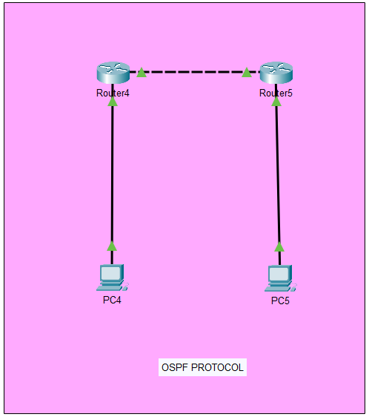

In the above architecture I have taken 2 PCs and 2 Routers.  
I have connected PCs to Routers via Copper Straight Through wire.  
I have connected Router to Router via Copper Cross-Over.

**PC Configuration:-**

On PC4:  
IP Address: 192.168.30.10

Subnet Mask: 255.255.255.0

Default Gateway: 192.168.30.1

On PC5:  
IP Address: 192.168.40.10

Subnet Mask: 255.255.255.0

Default Gateway: 192.168.40.1  
**Router Configuration:-**

On Router4:

enable

conf t

hostname R4

interface g0/0

ip address 192.168.30.1 255.255.255.0

no shutdown

interface g0/1

ip address 10.0.0.1 255.255.255.252

no shutdown  
router ospf 1

network 192.168.30.0 0.0.0.255 area 0

network 10.0.0.0 0.0.0.3 area 0

end

wr

On Router5:  
enable

conf t

hostname R5

interface g0/0

ip address 192.168.40.1 255.255.255.0

no shutdown

interface g0/1

ip address 10.0.0.2 255.255.255.252

no shutdown

router ospf 1

network 192.168.40.0 0.0.0.255 area 0

network 10.0.0.0 0.0.0.3 area 0

end

wr

**Connectivity:-**On PC4-ping 192.168.40.10  
On PC5-ping 192.168.30.10  
  
BGP PROTOCOL:-

BGP Protocol is a path vector protocol used for routing between autonomous systems on the internet.

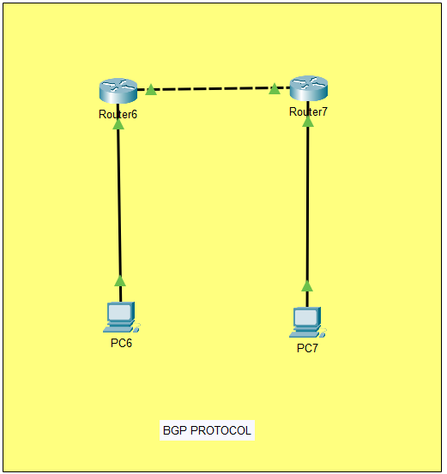

In the above architecture I have taken 2 PCs and 2 Routers.  
I have connected PCs to Routers via Copper Straight Through wire.  
I have connected Router to Router via Copper Cross-Over.

**PC Configuration:-**

On PC6:  
IP Address: 192.168.50.10

Subnet Mask: 255.255.255.0

Default Gateway: 192.168.50.1

On PC7:  
IP Address: 192.168.60.10

Subnet Mask: 255.255.255.0

Default Gateway: 192.168.60.1  
**Router Configuration:-**

On Router6:

enable

conf t

hostname R6

interface g0/0

ip address 192.168.50.1 255.255.255.0

no shutdown

interface g0/1

ip address 10.0.0.1 255.255.255.252

no shutdown

router bgp 65001

neighbor 10.0.0.2 remote-as 65002

network 192.168.50.0 mask 255.255.255.0

end

wr

On Router7:  
enable

conf t

hostname R7

interface g0/0

ip address 192.168.60.1 255.255.255.0

no shutdown

interface g0/1

ip address 10.0.0.2 255.255.255.252

no shutdown

router bgp 65001

neighbor 10.0.0.1 remote-as 65001

network 192.168.60.0 mask 255.255.255.0

end

wr

**Connectivity:-**On PC6-ping 192.168.60.10  
On PC7-ping 192.168.50.10

IGRP PROTOCOL:-

IGRP Protocol is a distance vector protocol developed by cisco for routing within an autonomous system it handles larger networks better then RIP

IS-IS PROTOCOL:-

IS-IS Protocol is a link state routing protocol used in routing in networks it is similar to OSPF Protocol but there is difference in implementation and use cases it operates at layer 2(DATA LINK LAYER) of OSI Model.